**Help To Buy ISA Mortgages**

**WTX Interface Functional Specification**

|  |  |
| --- | --- |
| **Interface Name:** | M156 - Help To Buy ISA Mortgages |
| **Version number:** | 1.1 |
| **Version date:** | 16 Jun 2016 |
| **Filename:** | IFS - H2B ISA Mortgages (M156) |
| **Author:** | Chris Clews/Ajay Mishra |
| **Owner:** | HCL WTX Team |
| **Status:** | New request |

**Change History**

|  |  |  |  |
| --- | --- | --- | --- |
| **Version** | **Date** | **Change Description** | **Author** |
| V0.1 | 10 Sep 2015 | Initial version | Chris Clews |
| V0.2 | 17 Sep 2015 | Changes as a result of review comments | Chris Clews |
| V0.3 | 24 Sep 2015 | Changes as a result of review comments / requirements | Chris Clews |
| V0.4 | 01 Oct 2015 | Change to the path names originally proposed | Chris Clews |
| V0.5 | 12 Oct 2015 | Phase 2 – added two reports + other minor changes | Chris Clews |
| V0.6 | 19 Oct 2015 | Additional changes, unrecognised files/error messages etc | Chris Clews |
| V0.7 | 04 Dec 2015 | Added the need to include some text in report trigger files.  Also added new error message MSG39 and included delivery to CRM DB via ODBC. | Chris Clews |
| V1.0 | 09 Mar 2016 | Baselined. | Chris Clews |
| V1.1 | 16 Jun 2016 | Section 5.2 updated to show the Email body contents for accepted and held file.  Section 3 update to have the new FilePath.txt as UKARcs moved to AssetCo share from Campus under Separation Phoenix.  Section 6 Appendix A is also updated. The string “Campus” has been replaced with “AssetCo” share in the document.  All changes were part of WOP after R2 and Separation Phoenix | Ajay Mishra |

**Approvals**

This document requires approval from the following.

| **Name** | **Title / Organisation** |
| --- | --- |
| Gary Marples | UKARcs Project Manager |
| Andy Colbourne | UKAR Architect |
| Sureshbabu Venugopal | HCL Project Manager |

**Distribution**

This document has been distributed to the following people / organisations.

| **Name** | **Title / Organisation** |
| --- | --- |
| Gary Marples | UKARcs Project Manager |
| Andy Colbourne | UKAR Architect |
| Sureshbabu Venugopal | HCL Project Manager |
| Jayasudha Patil | HCL Test Manager |
| Scott Cardow | UKAR Test Manager |
| H.D. Manjunath | HCL IT Architect |
| Chris Clews | HCL WTX Architect / Developer |

**Open Questions** (highlighted in yellow through the document)

* None

**Assumptions**

* The WTX interfaces will each take <5 minutes to run
* Data volume of individual files picked up will not be in excess of > 100mb

**Issues**

* None known

**Table of Contents**

1 Interface Description 5

2 Data Sources 6

3 Reference and Lookup Data 9

4 Data Targets and Mappings 11

5 Operational Information 13

6 Appendix A – Example of “H2B ISA Validation” report. 17

7 Appendix B – Example of “H2B ISA Status” report. 18

8 Appendix C – Example of “H2B ISA History” report. 19

9 Appendix D – Example of “Delivery Notification” for a report. 20

Purpose of this document

This document is a design work product. Its purpose is to document the detailed requirements for a WTX interface so that they can be agreed by HCL and UKAR.

It provides an overview of the interface, detailing source data, target data and any transformation rules that are needed.

The Interface Functional Specification (IFS) consists of the following chapters, each of which has a specific purpose:

Interface Description gives an outline of the interface in terms of the business requirement, the systems involved in the interface, the business events that trigger it and the main processing steps.

Data Sources defines each source system entity and its attributes. All attributes are listed, whether processed or not.

Reference and Lookup Data defines reference and lookup data used in the interface, e.g. Mapping Tables for converting a source account code to a target account code.

Data Targets and Mappings defines each target system data entity and its attributes. All attributes are listed, whether populated or not. All transformation rules are listed.

Operational Information contains information about additional output such as reports and e-mails and the day to day operation of the interface (including variations and exceptions to the normal processing flow, schedule information, messages, error and recovery, dependencies, volumes and security considerations).

# Interface Description

### Overview

The Help To Buy - ISA Mortgages WTX Project (M156) is required to receive files of data, monthly, from H2B ISA Managers who have signed up to this scheme. The data when received will be validated for integrity by the interface and if all data provided is acceptable, the data will be passed on to the next stage prior to input into the H2B ISA Mortgages Management application (due in Release 2). If any errors are found the whole file will be considered “rejected” and an error report indicating which records and which fields are in error will be generated, up to a maximum of 20 errors listed per file.

Note: “Release 1”, will receive, validate and store the data files, “Release 2” will include sending accepted data directly to the downstream application.

Every 5 minutes between 08:00 and 20:00, a poll will be made to our SFTP server (including weekends and bank holidays) to pick up any files that have been placed by the ISA Managers. A check will be made to see if this file has already been sent and accepted, based on the “Reporting_Month” value in the file. If it has, this file will not be passed on to the application, it will be placed in a “holding” area on the UKARcs P: drive and a message to this effect reported on the validation report. These files can be manually reviewed by the user with consultation with the ISA Manager, and if necessary the file can moved to the application for loading.

As with MGS Mortgages and Claims, ISA Managers will be able to submit test files (“TEST” in the file header) at any time. These will be validated as normal but the data will not be passed on to the application. “TEST” will normally be the initial submission type of the ISA Manager and once the files are sufficiently accurate, a flag will be set manually in an interface reference file “ActiveFlag.txt” to indicate that this ISA Manager is now “LIVE”. From this point on, files with “LIVE” in the file header will be accepted by the interface, but only if there are no validation errors, and the contents have not already been sent to the application. Note: This “onboarding” mechanism is a common to mortgage providers who wish to belong to the Mortgage Guarantee Scheme or ISA Managers scheme. There is also an “ActiveBrand.txt” reference file that is used, see below for more details.

Reports related to reception of files from ISA Managers will be provided in Excel format. These are scheduled but in some cases these reports can be generated “adhoc”. More details are provided later in this document.

**Logical Interface Diagrams**

The shaded areas are in scope of this WTX interface.

SFTP server

“Accepted” Folder

CSV files in ISA Managers’ folders

**WTX**

**Files copied**

**Transfer**

Upload

(Release 2)

Campus File Share

(P: Drive)

H2B ISA Application

“Held”   
Folder

“Rejected” Folder

Campus File Share

(P: Drive)

CSV files in Manual  
Transmissions folder

The following are specifically excluded from the scope of this WTX interface:

* Delivery of files to the ISA Managers’ folders on the SFTP server – done via the exiting “MGS” route.
* Upload of files from the Campus File Share to the H2B ISA Application – will be provided in Release 2.

# Data Sources

This section provides a complete list of all the input data files into WTX and all associated attributes.

Data Sources – Files of “H2B ISA” data received from ISA Managers

|  |  |
| --- | --- |
| **Type: (Extract File / Database Table / Query)** | File of type CSV, UNIX or DOS format – output files are always saved in DOS format. |
| **Description:** | These are CSV files containing data relating to ISA Managers’ H2B ISA accounts.  Expected volumes:  Approx. 10 files per month rising to 50 files per month, all received typically within the first 10 working days of the month.  Each file average in the first year of 3MB (20K accounts X record length of 150 chars) rising to a maximum size of 5.1MB (1.7M accounts over average of 50 ISA Managers) |
| **Filename:** | File names must be in the following format :  H2B_ISA_MMM_BBB_CCYY-MM.csv  Where:  MMM = ISA Manager’s code  BBB = ISA Manager’s Brand code (can be “VAR” for a file including various brands)  CCYY-MM = Reporting Month.  Only files with “ISA” somewhere in the name will be picked up by the interface, the name will be validated to check it matches the above format and an error produced if not, validation will continue for the file but the file will be marked as rejected.    Note: the values above, ISA Manager’s Brand code and Reporting Month, will be validated for integrity and also that they match the values in the file header. Note: If the Brand code is “VAR”, a separate check will be made to ensure that the various brand codes contained in the file are active brands using a reference file (see below). |
| **File Format** | File format should be comma delimited text in Windows DOS or Unix line format. |
| **Location:** | From a SFTP perspective, the files will mainly be placed, as with the Mortgage data files, in the folder relating to the Mortgage Lender or ISA Manager / Brand code relevant to the data content. There are two identical folder structures on the SFTP server, an “External Facing” one and an “Internal Facing” one. The ISA Manager can only place files into their specific folder based on the credentials they use to log in. Files are then automatically transferred from “External Facing” to “Internal Facing” where WTX can see them. An example of the folder structure that WTX sees on the SFTP server is this:  MGS_IN/BAR_WOO (for ISA Manager =Barclays, Brand=Woolwich)  MGS_IN/LBG_VAR (for ISA Manager =Lloyds Banking Group, Brand=[various]) |
| **Validation and processing:** | See table of error messages as a result of validations, below. |
| **Transfer method: (FTP / Connect Direct / MQ etc.)** | Files are transferred from the UKAR Prod SFTP server to WTX via FTP. |

**Input Validation, Status and Error Messages**

The below messages are output when either the file name, a field or a condition relating to a number of fields fails the check for data integrity or data content as described in the “Data Dictionary” (see section 2.2 below).

Where “&1” or “&2” is mentioned in the message, WTX will substitute a value for this place holder. Place holders are optional.

Note: These are “first guesses” as what text the message should contain, any of these can be amended as necessary in the “Messages.txt” reference file. The conditions that they relate to should be self-evident from the message content. It is expected that a review process would be needed to determine the final content.

MSG01 Validating file &1 using the &2 route.

MSG02 The file name does not contain a valid date in the format 'CCYY-MM', found &1.

MSG03 The file does not appear to have a valid 'header' line? The value of the first field in the first line should be 'H'.

MSG04 The 'header' line must contain 3 fields, it appears to have &1.

MSG05 The file 'intent' does not match 'intent' of the credentials used. Value should be '&1', found '&2'.

MSG06 The file appears not to contain a 'trailer' line.

MSG07 The last line of the file is not a 'trailer' line.

MSG08 The number of detail lines found does not match the number identified in the 'trailer', Actual=&1, Expected=&2.

MSG09 Line:&1 Field:3 'Brand' must be present and be of length 3 characters.

MSG10 Line:&1 Field:4 'Account Number' must be present and be of length 1-25 characters.

MSG11 Line:&1 Field:4 'Account Number' contains invalid characters.

MSG12 Line:&1 Field:5 'Account Balance' must be present and be of length 4-9 characters.

MSG13 Line:&1 Field:5 'Account Balance' is not numeric or not in the required format '9.99' or '-9.99'.

MSG14 Line:&1 Field:6 'Initial Subscripion Date' is not a valid date in the format 'CCYY-MM-DD'.

MSG15 Line:&1 Field:7 'Account Status' is not a valid value, it must be either '1', '2' or '3'.

MSG16 Line:&1 Field:8 'Account Closure Date' is not a valid date in the format 'CCYY-MM-DD'.

MSG17 Line:&1 Field:8 'Account Closure Date' must be present if 'Account Status' is '2' or '3'.

MSG18 Line:&1 Field:9 'Account Closing Balance' must be present and be of length 4-9 characters.

MSG19 Line:&1 Field:9 'Account Closing Balance' is not numeric or not in the required format '9.99' or '-9.99'.

MSG20 Line:&1 Field:9 'Account Closing Balance' must be '0.00' when 'Account Status' is '1'.

MSG21 Line:&1 Field:10 'Investor Date of Birth' is not a valid date in the format 'CCYY-MM-DD'.

MSG22 Line:&1 Field:11 'Investor Surname' must be present and be of length 1-50 characters.

MSG23 Line:&1 Field:12 'Investor Forename 1' must be present and be of length 1-50 characters.

MSG24 Line:&1 Field:13 'Other Names' length must not be greater than 50 characters.

MSG25 Line:&1 Field:14 'National Insurance Number' must be present and be in the correct format ('space' is allowed as 9th character).

MSG26 Line:&1 The 'detail' line must contain 14 fields, it appears to have &2.

MSG27 Line:&1 Field:3 'Brand must be the same as the brand in the file name.

MSG28 Line:&1 Field:3 'Brand is not a valid brand.

MSG29 Line:&1 Field:2 'ISA Manager Reference' is not a valid value, it must be in the format 'Znnnn' where 'n' is a numeric digit.

MSG30 The file header 'Reporting Month' is not a valid date in the format 'CCYY-MM', found &1.

MSG31 The file header 'Reporting Month' '&1' does not match the reporting month in the file name '&2'.

MSG32 Line:&1 Field:3 'Brand' is not an active brand.

MSG33 The 'intent' of the file is 'LIVE' but the Active Flag is not set for this ISA Manager.

MSG34 The file header 'Reporting Month' cannot be the current month or a future month, found '&1'.

MGS35 Line:&1 Field:11 'Investor Surname' contains invalid characters.

MGS36 Line:&1 Field:12 'Investor Forename 1' contains invalid characters.

MGS37 Line:&1 Field:13 'Other Names' contains invalid characters.

MGS38 The file name '&1' is not in the correct format of 'H2B_ISA_III_BBB_CCYY-MM.csv' (III=ISA Mgr code, BBB=Brand Code)

MSG39 Line:&1 Field:8 'Account Closure Date' must NOT be present if 'Account Status' is '1'

Data Sources – Files of “H2B ISA” data, file Layout.

**Header**

**Field Name** **Format**

Record_Type Char 1 "H"

File_Intent Char 4 i.e. one of "TEST", "LIVE"

Reporting_Month Date 7 i.e. "2015-12"

**Detail**

|  |  |  |  |
| --- | --- | --- | --- |
| **Field Name** | **Format** | **Length** | **Contents** |
| Record_Type | Char | 1 | "D" |
| ISA Manager Reference | Char | 5 | i.e. “Z1234” |
| Brand | Char | 3 | i.e. “ULB” (cannot be “VAR”) |
| Account_Number | Char | 0-25 | i.e. "1234-56789ABCDEFG.hijklmn" (see note below) |
| Account_Balance | Decimal | 9 | i.e. -4.99 |
| Initial_Subscription_Date | Date | 10 | i.e. "2000-01-01" |
| Account_Status | Char | 1 | i.e. "2" |
| Account_Closure_Date | Date | 10 | i.e. "2015-05-01" |
| Account_Closing_Balance | Decimal | 9 | i.e. -0.49 |
| Investor_Date_of_Birth | Date |  | i.e. "1961-12-28" |
| Investor_Surname | Char | 0-50 | i.e. "Smith " |
| Investor_Forename_1 | Char | 0-50 | i.e. "John" |
| Other_Names | Char | 0-50 | i.e. "Alexander Matthew" |
| National_Insurance_Number | Char | 9 | i.e. "NE961234A" (validated as XXNNNNNNX – Last character can be a space) |

**Trailer**

**Field Name** **Format**

Record_Type Char 1 "T"

Record_Total Integer 7 i.e. 1

Attached below is the Data Dictionary document to which the above refers:



Note: The following list of characters are allowed in the “Account Number” field:

Upper case alphabet A to Z  
Lower case alphabet a to z   
Numbers 0 to 9   
Space Oblique / Hyphen –   
Ampersand & Full stop .   
Apostrophe ‘ Left Hand Parenthesis ( Right Hand Parenthesis )

The following characters must not be used

Asterisk *   
Comma ,   
Semi-colon ;   
Vertical Bar |

# Reference and Lookup Data

This section provides a complete list of all the reference data files used and all associated attributes.

Reference and Lookup files.

**File: ActiveBrand.txt**

Layout:

Field Name **Format Length**

Manager_Brand_Code Char 7 i.e. “RBS_VAR”  
Brand_Code Char 1 i.e. “NAT”

Example:

RBS_VAR,RBS

RBS_VAR,NAT

LBG_VAR,HFX

**File: ActiveFlag.txt**

Layout:

Field Name **Format Length**

Manager_Brand_Code Char 7  
Active_Flag Char 1 i.e. “Y” or “N” (capitalised)

Email_Address Char 0-50 (optional)

Example:

RBS_VAR,Y,ISA-Mortgages@rbs.co.uk

RBS_ULB,Y,mortgagesdepartment@ulsterbank.co.uk

BAR_WOO,Y,ISADept@woolwichbuildingsociety.co.uk

VRG_VRG,Y,virginmoneymatters@virginmoney.com

**File: Messages.txt (fixed length file)**

Layout:

Field Name **Format Length**

MSG_Code Char 5  
Filler Char 1 (space)  
MSG_Text Char 250

Example:

MSG01 Validating file &1 using the &2 route.

MSG02 The file name does not contain a valid date in the format 'CCYY-MM', found &1.

Note: in the 1st example above WTX would replace &1 with the filename and &2 with “LIVE”.

**File: FileHist.txt**

Layout:

Field Name **Format Length**

Manager_Brand_Code Char 7  
Reporting_Month Date 7

DateTime_Received Datestamp 15 i.e. format “CCYYMMDD_HHMMSS”

Status Char 3 i.e. one of “ACC”, “REJ”, “HLD”

(Note: Archiving, when records become over a year old, they will be removed from the file)

Example:

RBS_ULB,2015-11,20151202_124505,ACC

BAR_WOO,2015-11,20151202_124507,ACC

BAR_WOO,2015-10,20151202_125005,REJ

RBS_ULB,2015-11,20151202_152511,HLD

LBG_VAR,2015-11,20151203_082017,HLD

The following reference files contain unformatted data only.

**File: Character_Set_Mask.txt**

Length 256 characters. Each character and its position represents a corresponding character in the existing ASCII character set in order to determine invalid characters received in a data field.

**File: Email_Control.txt**

Length 250 characters .The default email address to send reports i.e. “H2BISANotifications@ukarcsl.co.uk”

**File: FilePath.txt**

5 records, the data is as follows:  
  
UKARcs moved to AssetCo share, so the FilePath.txt file is updated with below information

\\live.internal\AssetCo\UKARCS\H2B_ISA_MGR_DATA\Live\Accepted\

\\live.internal\AssetCo\UKARCS\H2B_ISA_MGR_DATA\Live\On Hold\

\\live.internal\AssetCo\UKARCS\H2B_ISA_MGR_DATA\Live\Rejected\

\\live.internal\AssetCo\UKARCS\H2B_ISA_MGR_DATA\Test\Accepted\

\\live.internal\AssetCo\UKARCS\H2B_ISA_MGR_DATA\Test\Rejected\

Note: These paths can be modified as required.

# Data Targets and Mappings

This section provides a complete list of all the output data files from WTX and all associated attributes.

Data Targets – Files of “H2B ISA” data received from ISA Managers

|  |  |
| --- | --- |
| **Type: (File / Database Table / Report / Email)** | (same as data source) |
| **Description:** | (same as data source) |
| **Filenames:** | Same as data source but with “CCYYMMDD_HHMMSS__” prefixed to the name.  This is a date time stamp for uniqueness. |
| **File Format** | (same as data source) |
| **Location:** | There are 5 possible locations for the file depending on the outcome of the validation.  UKARcs AssetCo FileShare “Accepted” folder: P:\UKARcs\H2B_ISA_MGR\Live\Accepted\  UKARcs AssetCo FileShare “On Hold” folder: P:\UKARcs\H2B_ISA_MGR\Live\On Hold\  UKARcs AssetCo FileShare “Rejected” folder: P:\UKARcs\H2B_ISA_MGR\Live\Rejected\  UKARcs AssetCo FileShare “TEST Accepted” folder: P:\UKARcs\H2B_ISA_MGR\Test\Accepted\  UKARcs AssetCo FileShare “TEST Rejected” folder: P:\UKARcs\H2B_ISA_MGR\Test\Rejected\  Note: There is no TEST Holding folder used by the interface, Test files are either accepted or rejected. |
| **Processing:** | None – file contents are unchanged. |
| **Transfer method: (FTP / Connect Direct / MQ etc.)** | Files copied to the folder by WTX. |

Data Targets – Data loaded to the R1B database.

|  |  |
| --- | --- |
| **Type: (File / Database Table / Report / Email)** | Database table |
| **Description:** | Staging table for ISA Manager Data |
| **Filenames:** | N/A |
| **File Format** | N/A |
| **Location:** | TEST:R1B: Ukardwltcvvh15\INST05  TEST:CRM:VPN IP address 172.16.1.69  LIVE:R1B (TBA)  LIVE:CRM (TBA) |
| **Processing:** | Mapping of fields from input (see below). |
| **Transfer method: (FTP / Connect Direct / MQ etc.)** | Data is inserted into the database table using ODBC. |

Table Name - stg.ISAccountFromWTX

|  |  |  |  |
| --- | --- | --- | --- |
| **Field Name** | **Format** | **Length** | **Contents** |
| ISAManagerReference | VarChar | 5 | All below, equivalent fields on input. |
| Brand | VarChar | 5 | “ |
| Account_Number | VarChar | 25 | “ |
| Account_Balance | Decimal | 19 | “ |
| Initial_Subscription_Date | TimeStamp | 23 | “ |
| Account_Status | VarChar | 1 | “ |
| Account_Closure_Date | TimeStamp | 23 | “ |
| Account_Closing_Balance | Decimal | 19 | “ |
| Investor_Date_of_Birth | VarChar | 10 | “ |
| Investor_Surname | VarChar | 50 | “ |
| Investor_Forename_1 | VarChar | 50 | “ |
| Other_Names | VarChar | 50 | “ |
| National_Insurance_Number | VarChar | 9 | “ |
| ReportingMonth | VarChar | 8 | Reporting Month from File Name |
| ProcessingStatus | CarChar | 20 | TBA |

# Operational Information

This section relates to the implementation and management of the Interface.

## Transfer and Transformation.

1. WTX polls each ISA Managers’ folders every 5 minutes for files (this is the same as for MGS mortgages and claims files).
2. WTX polls the P:\UKARcs\H2B_ISA\ManualSubmissions folder every 5 minutes.
3. On receipt of a file, the file is validated for structural integrity and data integrity. The reference files described above are used in this validation to determine the outcome of the validation rules. A full list of the current error messages can be found above.
4. Up to 20 error messages will be provided on an email which will be sent to UKARcs, and the ISA Manager (if an email address has been supplied in the reference file - see above). The actual error messages will be held in an external reference file for ease of amendment (also see above). Also, the UKARcs recipient of the email will be a “blind copy” and the email will state the following:  
     
   *** Please do not reply to this email *** Please note this email notification has been sent from an email address that is not monitored. Please email ' H2BISANotifications@UKARcs.co.uk' if you have any questions relating to this notification.  
     
   If error messages have been issued, the file will be placed in the “Rejected” folder. If the file has no errors but we’ve already accepted a file for this reporting month, it will be placed in the “Holding” folder, otherwise the file will be placed in the “Accepted” folder and an entry added to “FileHist.txt”, with a “Status” value of “ACC”. Note: If there are no errors and the file was sent via the MANUAL route, the file will always be accepted. Values of “REJ” and “HLD” will be applied to the former two conditions respectively. If there are no error messages, a summary only email will be sent.
5. If the file was sent with “TEST” in the file header the results of validating the file are reported as normal by email to UKARcs and the ISA Manager. The file is then copied to the requisite folder but one that resides under a subfolder of “TEST”. The proposed P: folder structure is described below:  
     
   UKARCS  
    H2B_ISA_MGR  
    ISA_ManualSubmission  
    Live  
    Accepted  
    On Hold  
    Rejected  
    Reports  
    Test  
    Accepted  
    Rejected  
     
   If the file was sent with “LIVE” in the file header and it was accepted, the contents of the file will be immediately uploaded to the CRM database (see Data Targets section).
6. Any files found in the “ISA_ManualSubmission” folder will be treated as if they have come through the LIVE credential route, but any emails generated will not be sent to the ISA Manager, only UKARcs. UKARcs can forward the email if they deem it necessary.

The “ISA_ManualSubmission” folder can also accept requests to run reports. If a “trigger” file containing some text is placed in this folder, WTX will run the respective report to the “Reports” folder. The reports will be formatted in Excel, WTX will just populate “Tab 2” in the spreadsheet whilst the report is formatted on “Tab 1”. An email will be sent to the “H2BISANotifications” mailbox with a link to the report that has just run.  
  
H2B_ISA-History_Report.trg runs the H2B ISA “History” report.  
H2B_ISA-Status_Report.trg runs the H2B ISA “Status” report.

These reports will also be scheduled to run once a month (times TBA).

**History Report**

This report shows a list of the most recent 10 “events” related to each ISA Manager for the current month and previous 11 months. The list of possible events are “Accepted”, “Rejected”, “On Hold”.

**Status Report**

This report shows the final status for each ISA manager for the current month and previous 11 months. A “tick” in the column shaded in green indicates that the last file received was “accepted”, however if the status for the last file was “rejected” or “on hold” then a “cross” shaded in red is shown. If no files have been received for this ISA manager in a month, they column is shown blank.

Please see the appendices for examples of these reports.

## E-mails and Reports to be generated

The standard technical alert emails are to be produced for WTX Support.

After processing a notification email report is sent to “H2BISANotifications” and, if applicable, the ISA Manager detailing the success or failure of the interface. Note: Failures related to file structure and data content only will be reported. System errors will be reported to HCL BAU as usual.

**Email contents changed as per the R2 requirement(Accepted and on-Hold) :-**

**An example of the existing Successful to 'Accepted' folder email is :**   
  
  
Thu 14 Apr 2016 15:36:11 UKARcs H2B ISA Mortgage Interface WTX File Validation Report - Successful  
  
*** Please do not reply to this email *** Please note this email notification has been sent from an email address that is not monitored. Please email 'ISAInterfaceNotifications@ukarcsl.co.uk' if you have any questions relating to this notification.  
  
MSG01 Validating file H2B_ISA_CBD_CBD_2016-03.csv using the MANUAL route.  
  
  
  
Reporting month '2016-03' processed successfully - file saved in 'ACCEPTED' folder  **The business require the last sentence change to :**  
  
  
Reporting month '2016-03' initial validation processed successfully, exception checks taking place - file saved in 'ACCEPTED' folder  **An example of the existing Successful to 'On Hold' folder email is :**   
  
  
Thu 14 Apr 2016 09:40:45 UKARcs H2B ISA Mortgage Interface WTX File Validation Report - Successful  
  
*** Please do not reply to this email *** Please note this email notification has been sent from an email address that is not monitored. Please email 'ISAInterfaceNotifications@ukarcsl.co.uk' if you have any questions relating to this notification.  
  
MSG01 Validating file H2B_ISA_CBD_CBD_2016-03.csv using the LIVE route.  
  
  
  
Reporting month '2016-03' has already been processed - file saved in 'ON HOLD' folder  **The business require the last sentence change to :**  
  
  
Reporting month '2016-03' has already been processed initial validation processed successfully, exception checks taking place - file saved in 'ON HOLD' folderd

An example of this email report can be seen in Appendix A. Further reports are also available.

## Interface Schedule

The SFTP interface is set to run every 5 minutes during the day between 8am and 7pm 7 days a week and “ISA_ManualSubmission” interfaces follows the same interval but runs only Mon-Fri. For TEST files it will be the same times however only working hours Monday to Friday. Transfers of any files found to the ISA Managers’ folders will be immediate. Note: After processing the files will be removed from the source folders on the SFTP server.

## Interface Initiation

The interfaces are initiated by the Router Scheduler. The scheduler runs every minute 24 hours a day 7 days a week, except for 15 minutes between 00:00 and 00:15 which is reserved for system housekeeping.

## Data Archiving and Retention

WTX is to keep a copy of all H2B ISA input files for 2 weeks for the purposes of recovery. When files become 2 weeks old they will removed by the standard WTX Archiving utility.

Data records held on the “FileHist.txt” reference file will kept for a year depending on the date in the record.

## Error and Recovery

If the interface fails for any technical reason, then an e-mail is generated and sent to the HCL WTX team for them to investigate the problem.

If the interface fails due to unable to access resource for instance, it will run when the resource is made available again and catch up any files that have been placed in source locations in the meantime.

BAU will be monitoring for alerts to make sure that any downtime will be kept to a minimum. Any downtime at all for this interface would be very unusual.

## Operational Dependencies

WTX will ensure the interfaces don’t run around the times of the following daily events:

* WTX Generic Router archiving (00:00 – 00:15 every day)

Note: folder cycling has been replaced by the WTX Generic Router archiving.

## Operational Controls

Standard WTX operational controls will be put in place for this interface.

## Volumes

The volumes are small so there is sufficient disk capacity available at present to support this interface.

## Security Considerations

This interface is to re-use the existing credentials for the FTP Gateway and Campus File Share.

## Ongoing Maintenance

There is no ongoing maintenance for this interface.

# Appendix A – Example of “H2B ISA Validation” report.

From: [WTX_Prod_HCL@bbg.co.uk](mailto:WTX_Prod_HCL@bbg.co.uk)   
To: [SavingsOperationsUKARReporting@virginmoney.com](mailto:SavingsOperationsUKARReporting@virginmoney.com)   
Cc: [WTX_Prod_HCL@bbg.co.uk](mailto:WTX_Prod_HCL@bbg.co.uk)   
Date: 14/06/2016 11:19   
Subject: H2B_ISA_VRG_VRG_2016-05.CSV received: Successful

Tue 14 Jun 2016 11:16:17 UKARcs H2B ISA Mortgage Interface WTX File Validation Report - Successful  
  
*** Please do not reply to this email *** Please note this email notification has been sent from an email address that is not monitored. Please email 'ISAInterfaceNotifications@ukarcsl.co.uk' if you have any questions relating to this notification.  
  
MSG01 Validating file H2B_ISA_VRG_VRG_2016-05.CSV using the LIVE route.  
  
  
  
Reporting month '2016-05' initial validation processed successfully, exception checks taking place - file saved in 'ACCEPTED' folder

The data submitted that produced the above report is as follows:

H,LIVE,2015,Z1234

D,ZZ123,NXX,1234_56789ABCDEFG.hijklmn,-4.999,2000-02-30,2,2015-22-01,-100000.00,1961-12-28,Smith,John,Alexander Matthew,NE96123A

D,Z1234,RB,1235&65789ABCDEFG.hijklmn,-824.34,2000-01-01,2,2015-05-01,,1965-10-06,,J,,NL961234A

D,Z1234,RBS,A45-2046,1000.00,2008-05-04,3,,0.00,1963-08-16,Davies,Jon,Edward,NL961234A

D,Z1234,RBS,A45+2046,1000.00,2008-05-04,3,,0.00,1963-08-16,Davies,Jon,Edward

T,3

# Appendix B – Example of “H2B ISA Status” report.

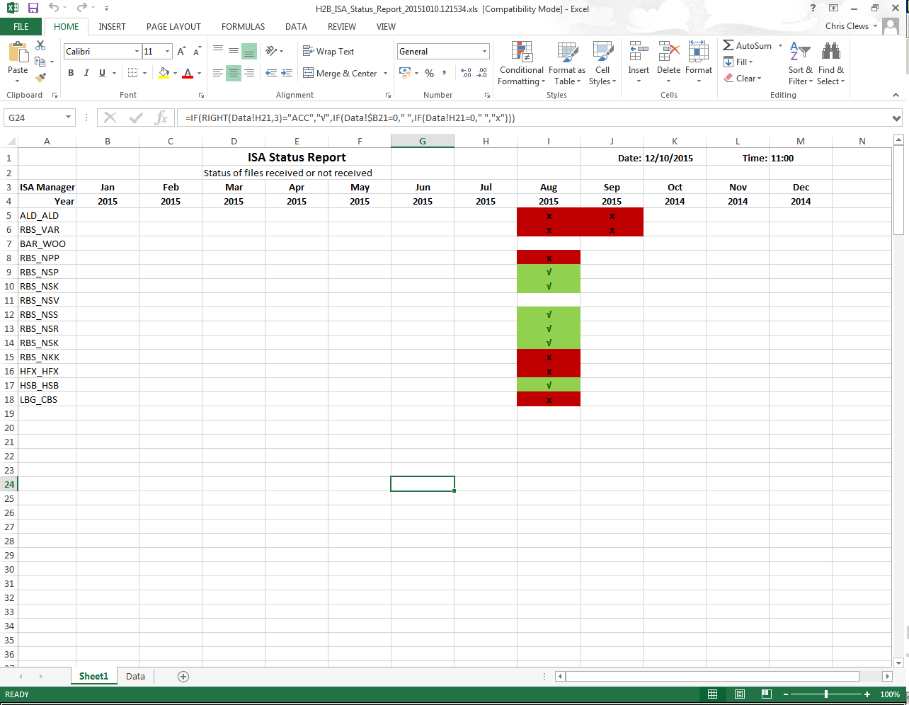

Note: The columns in this report and the following report are static. In this report the applicable year is shown under the month. As can be seen the “current” month is September as this report was run during October, and the year under “October” is the previous year.

# Appendix C – Example of “H2B ISA History” report.

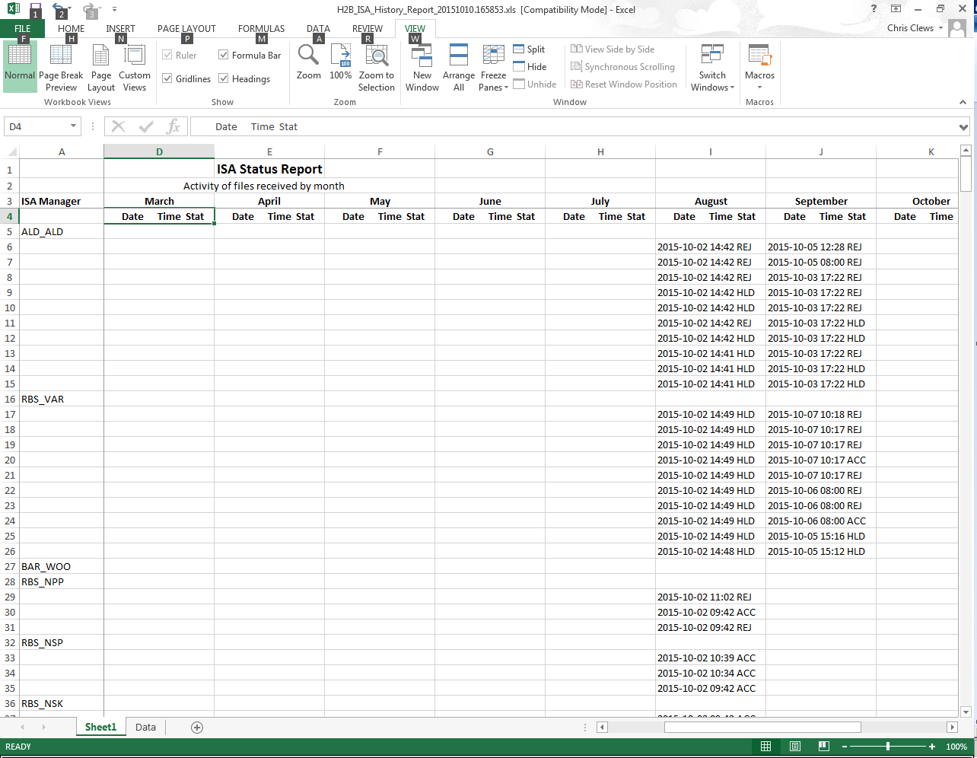

Note: The report starts from “January” in the left column, however the report uses “Freeze Panes” to allow scrolling so the ISA Manager column is always visible.

# Appendix D – Example of “Delivery Notification” for a report.

From: WTX_Prod_HCL@bbg.co.uk

To: H2BISANotifications@ukar.co.uk

Cc: WTX_Prod_HCL@bbg.co.uk

Date: 11/10/2015 17:15

Subject: H2B_ISA-Status_Report requested

Sun 11 Oct 2015 17:15:20 UKARcs H2B ISA Report Request  
  
Please click below link to open the report.  
  
File://P:\UKARcs\H2B_ISA_MGR\Reports\H2B_ISA_Status_Report_20151011.171520.xls